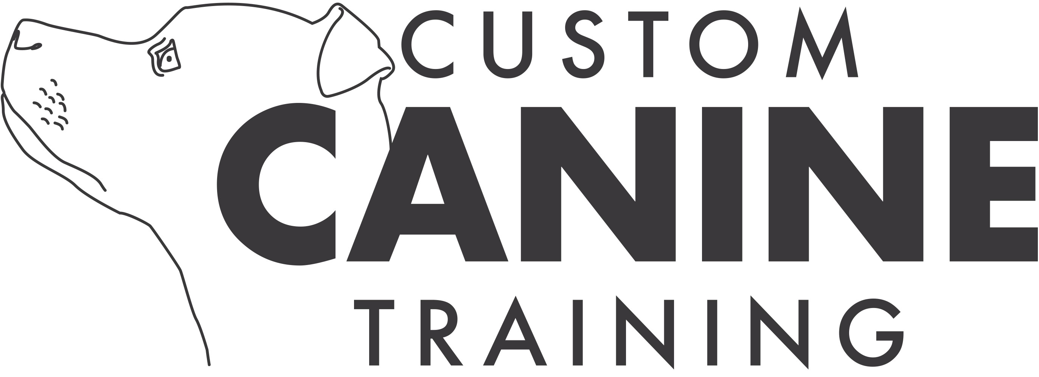
Custom Canine Boatyard Bonanza
5th January 2020

With thanks to: J.D. Boat Services Gailey Ltd
The Wharf
Watling Street
Gailey
Staffs
ST19 5PR

Limited to 20 dogs. Closing Date 29/12/19. Entries will close sooner if maximum number of dogs is reached.

Show opens: 9:00am
Judges' briefing: 9:15am
Judging commences: 9:30am – Novice and Intermediate levels will run concurrently. There is no Advanced level offered at this trial.

Set block of 3 searches (1 Interior; 1 Exterior and 1 Games). £22 per dog.

Please send entries to: vay.coltrose@gmail.com
Fees by bank transfer to: Custom Canine; 12213814; 08-92-86

Directions to the Venue:
If you're coming from the M6, exit at Jct 12 onto the A5 towards Telford. The entrance to the Marine is on the left, about 400m after the entrance to the quarry.
From Telford, it's on your right just after you go over the canal, and just after a rounded building, also on your right.

Awards:
Trophies in all classes (Interior, Exterior at each level and Games ). Rosettes 1-6th place for each of the interior and exterior searches; 1-6th place for the games (all teams compete together in Games, regardless of level). “Clean Sweep” rosettes for unplaced teams who find all hides within the allotted time.

Eligibility:
Handlers may decide at which level they choose to enter their dog. The following is a guide as to which level to enter, but it is at the handler's discretion:

Novice: for dogs who are working at level 1-2 at Scentwork UK.
Intermediate: for dogs who are working at level of 3-5 Scentwork UK

Search Rules:

- The target odor is cloves. The scent article may be of any material shown to hold the scent.
- All searches are “area” searches - the hide may be anywhere within the marked area, but will be positioned such that it is easily accessible to dogs of all sizes.
- All searches will have multiple hides: Novice: 2-3 hides. Intermediate: 3-5 hides.
- 10 points for each correct 'find'.
- Points will be deducted as follows:
a) Eliminating in the ring: 10 points.
b) Calling a “false alert”: 5 points.
c) Rewarding with food or toys in the ring: 5 points.
d) Destructive behaviour in the search area: 2 points
e) Swallowing the scent article: 2 points
f) Handler touching items/surfaces in the search area: 2 points
- The running order will be displayed from the morning of the trial.
- At the beginning of the search the judge will tell the competitor how many hides are hidden and the maximum allowed time.
- The timer will start as soon as the dog's nose passes through the markers.
- The dog may work on lead, off lead, or some of the search on and some off.
- The handler may take their dog out of the search area to reward their dog after each find. For Novice dogs, the timer will be stopped. For Intermediate dogs the timer will not be stopped.

Games Rules:
Speed Search – There will be a large number of hides. The team that finds the most hides in the allotted time wins. In case of a tie, the team that found their first hide the soonest will be placed higher.
Novice and Intermediate dogs compete together in this part of the trial. The handler may take their dog out of the search area to reward their dog after each find. For Novice dogs the timer will be stopped. For Intermediate dogs the timer will not be stopped.

Show Rules:
Please read carefully, you agree to abide by them when signing the declaration.
- The Judge's decision is final
- Custom Canine reserves the right to refuse entries.
- Entries limited to 20 dogs.
- If the maximum number of dogs is reached before the closing date, entries will be closed at an earlier date.
- One handler may work more than one dog either in the same level or different levels.
- Dogs may be entered at whichever level the handler chooses.
- Competitors must sign and date the declaration on the entry form.
- Dogs must be on lead at all times unless under trial. Please give all other dogs plenty of space, not all want to “say hello”.
- Competing dogs must be over 6 months of age on the day of the trial.
- Bitches in season are not allowed to compete.
- It is the competitor's responsibility to be available for their search on time.
- Dogs may wear a flat collar or non-restricting harness while competing. No other collar or harness may be used (e.g. slip lead, restrictive or tightening harness)
Dogs may wear a vest or bandana.
- Handlers may have food and/or toys with them in the search area, but must leave the designated area before rewarding their dog.
- Any person handling their own or any other dog in a harsh manner will be asked to leave the trial.
- A dog will be removed from the venue if: they are deemed so out of control they may be a danger to people or dogs; if they are suffering from an infectious disease; or if they are otherwise unfit to compete.
- In the unlikely event that the trial needs to be cancelled, Custom Canine reserves the right to deduct unrecoverable expenses incurred before returning fees.
- No entry will be accepted without fees.
- All dogs are entered at their owner's risk. While every care will be taken, Custom Canine will not be held responsible for loss, damage or injury to people, dogs or property, however caused.
- Spectators are allowed, except for competitors competing at the same level who have not yet searched that area.

